**_________________________________________**

**Developer: --** RAVI KASHYAP

**GitHubLink:**

**-:Retrieving the Product Details Using the Product ID.: -**

__________________________________________________________________________________

**DESCRIPTION**

**Project objective:**

Create a servlet-based application that shows a form to enter a product ID. The product ID is then validated, and product details are retrieved from the database and displayed to the user. You need to create a product table in MySQL and prepopulate it with data. Use JDBC to do all database processing.

**Background of the problem statement:**

As a part of developing an e-commerce web application, the admin backend requires a module that can retrieve product information based on the product ID.

**Features: -**

Basic index form for takin the input from user(ProductID).

Verifies the data from database

On success brings user to Product detals

**Algorithm:--**

1. Start by creating a 'Dynamic Web Project' in Eclipse
2. Create a index.html page
3. Set html form with action RetrieveData''
4. Create 'do*Get*' servlet
5. Select 'service' method upon creation
6. Instantiate RequestDispatcher

**Flowchart:--**

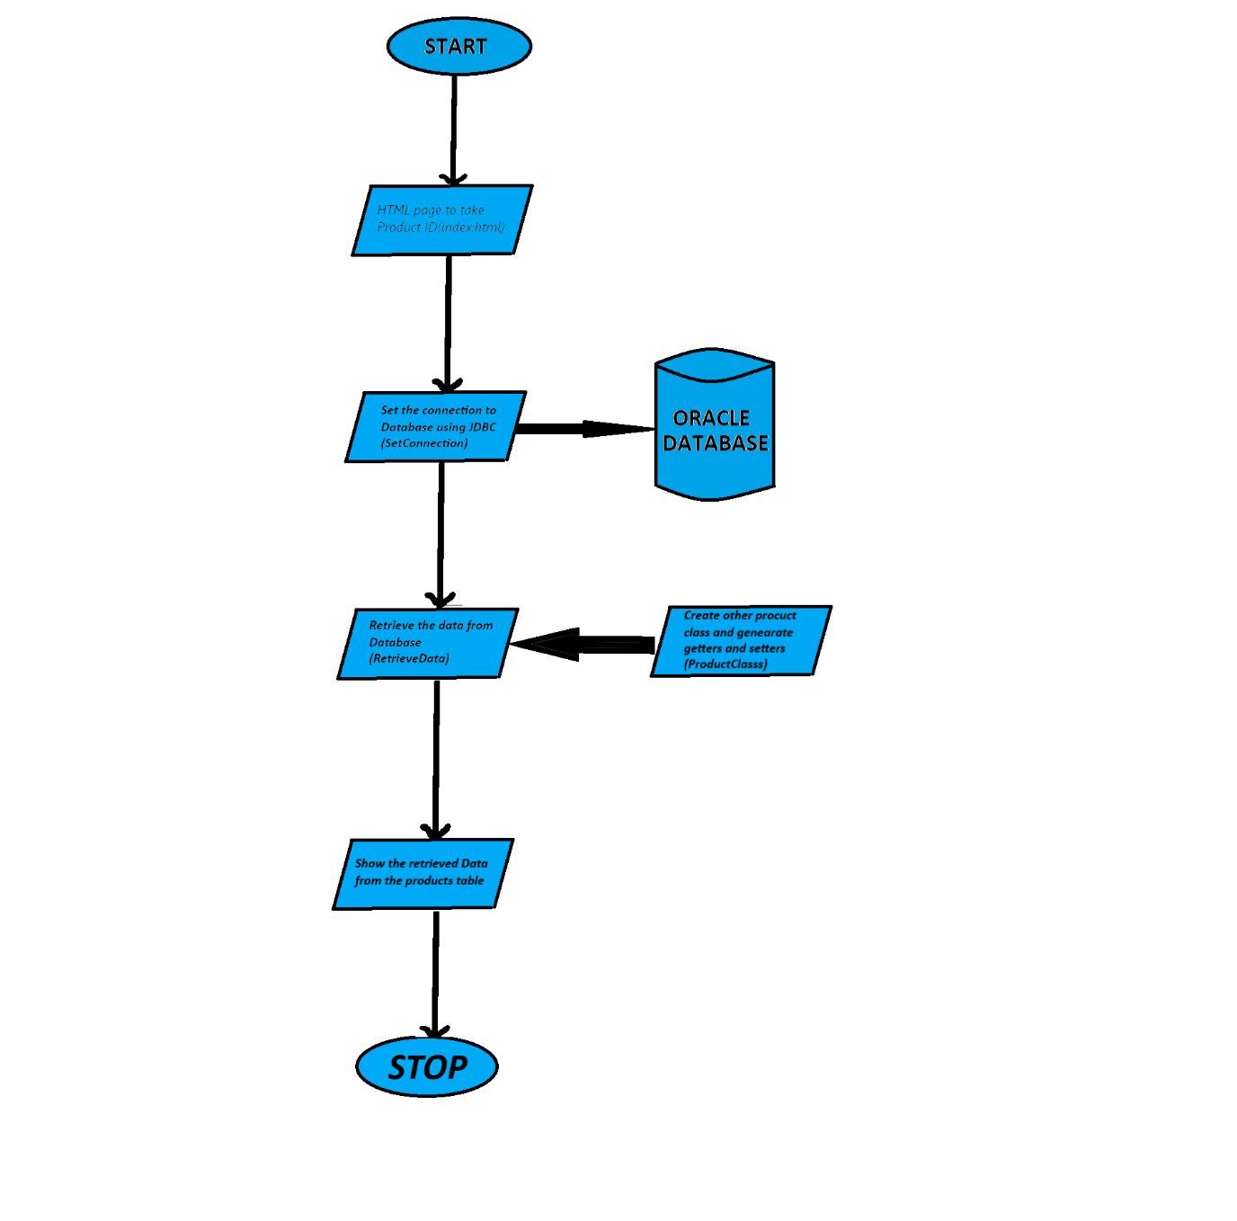

**Screenshorts:--**

1.

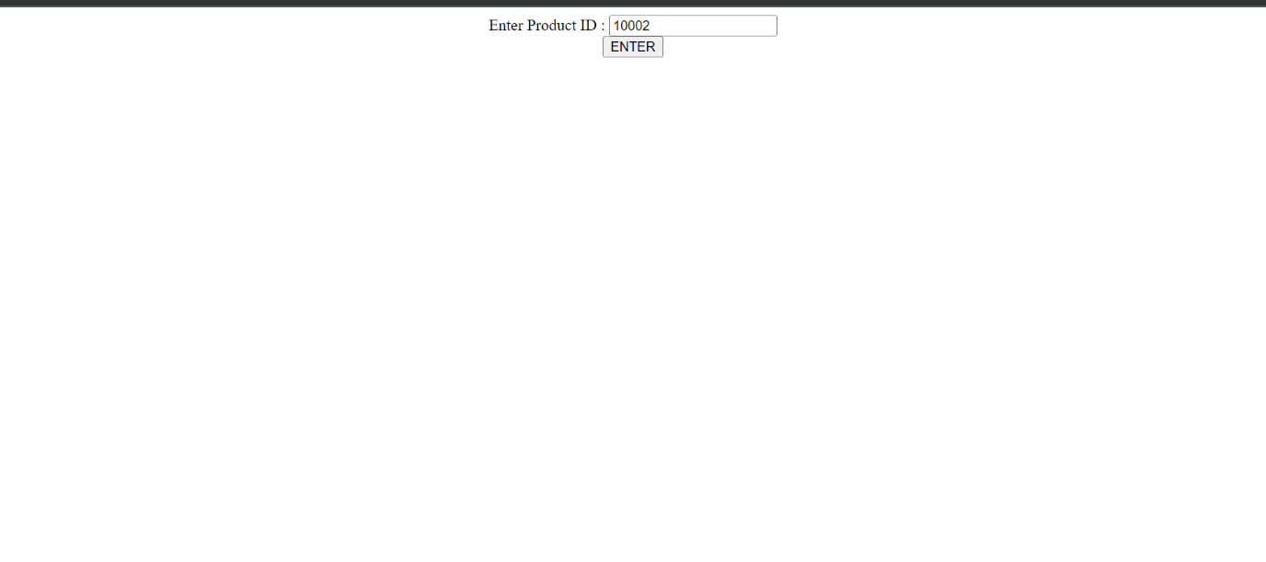

**________________________________________________________________**

2.

